March 2022 | 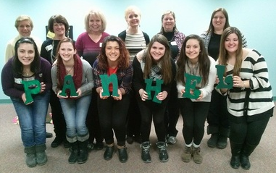
Sunday | Monday | Tuesday | Wednesday | Thursday | Friday | Saturday
 |  | 1 | 2 | 3 | 4 | 5
6 | 7 | 8 | 9 | 10 | 11 | 12
13 | 14 | 15 | 16 | 17 | 18 | 19
20 | 21 | 22 | 23 | 24 | 25 | 26
27 | 28 | 29 | 30 | 31

Thursday March 10, 2022
6:30pm YAPA Meeting
Boardman United Methodist Church
6809 Market Street, Youngstown, Oh. 44512

